Alexander Cannell

CSIS 4700

Professor Robertson

SPAM Practice

Introduction:

This is a criminal case were we are looking at spam on a computer. I’m using FTK to analyze this evidence.

Examination:

Add Spam.E01 as evidence

1. How many e-mail archives are found?

I found 2,194 emails.

1. How many total messages?

Of those emails I found 2,172 messages.



Perform a live search for "pharmacy"

1. How many files were found?

I got 13 hits found in 3 files.

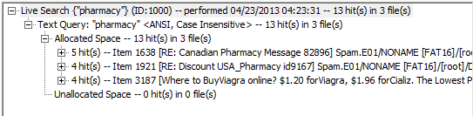

Do another live search for "viagra"

1. Compare your results with an index search for "viagra"

I got 18 hits found in 3 files.

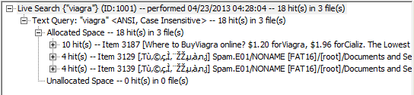

1. Why do the results differ?

The Index search came up with a lot more hits and a lot more files. I think it is because FTK is searching through and index.

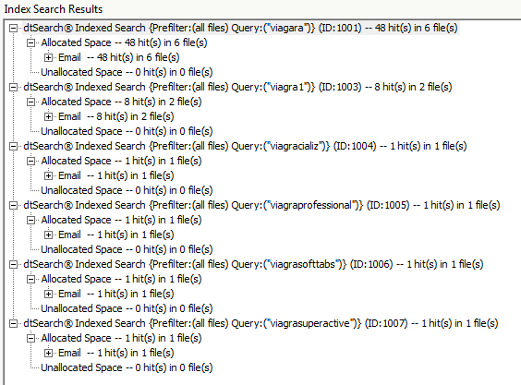

Review findings from your searches

1. What evidence is there that these messages are related?

THE EMAIL THAT SHOWED UP IN BOTH SEARCHES.



LIVE SEARCH

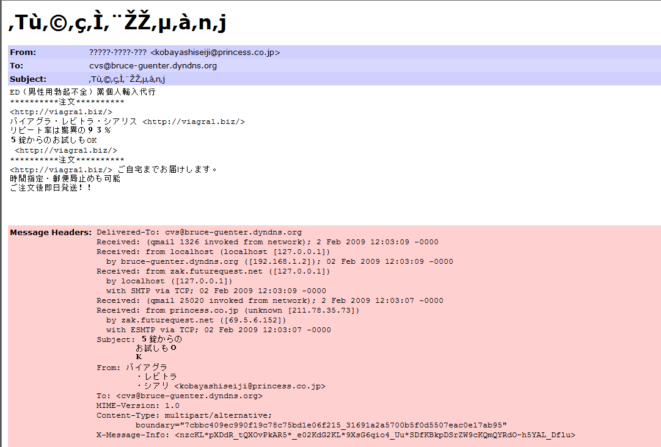

INDEX SEARCH

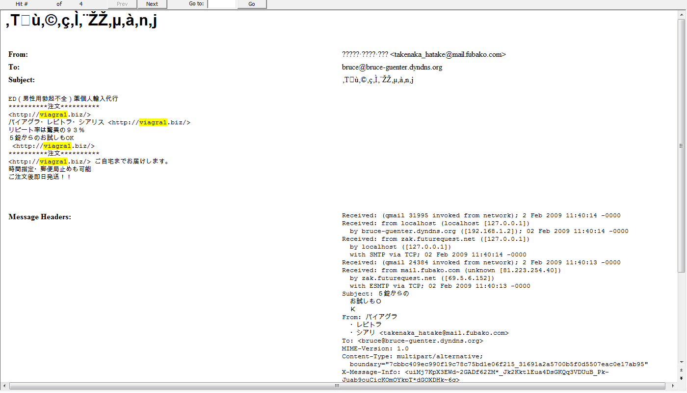

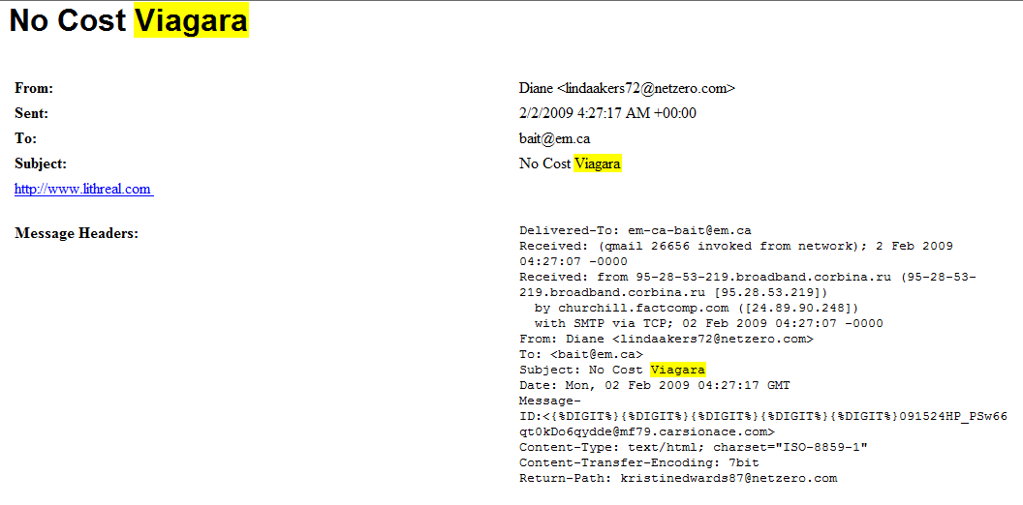

What pharmacy site(s) was this person working for?

ViagraCializ, ViagraProfessional, CialisProfessional, ViagraSuperActive, CialisSuperActive, Levitr, ViagraSoftTabs, CialisSoftTabs, VPXL, S@MA, Revatio, LevitraProfessional, FemaleViagrz, Tramadol, Propecia, Ultram, Acomplia, Phentrimine, Xenica1, LevitraSuperActive, and viagra1.biz

Do we have any clues to his/her identity?

I would suspect that it’s a male, and his name is Bruce Genter because of the email addresses [bruceg@em.ca](mailto:bruceg@em.ca), [Bruce@bruce-genter.dyndns.org](mailto:Bruce@bruce-genter.dyndns.org), and [bruce@untroubled.org](mailto:bruce@untroubled.org).

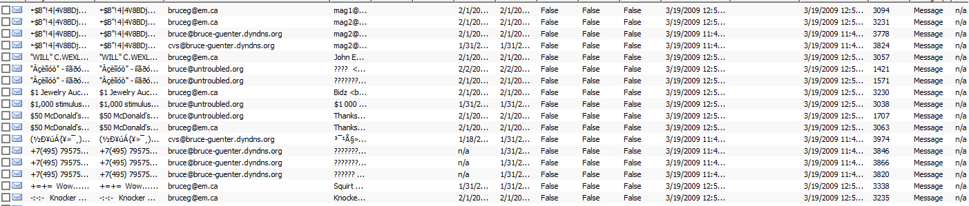

Where might this person be located?

He could be Canadian



He could also be Russian

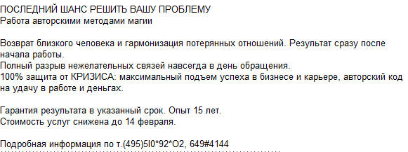

He could also be from the united states, I would think most likely he is, with an name like bruce, or the UK.

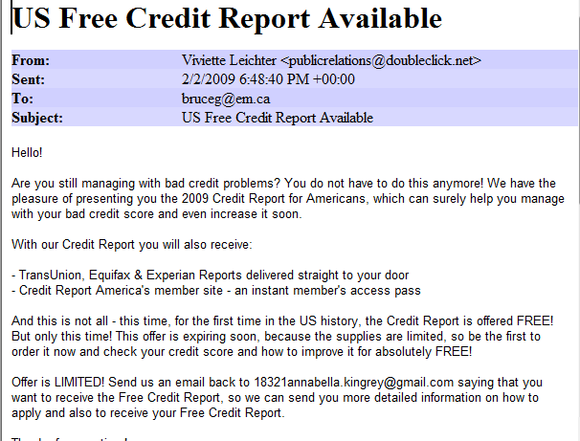



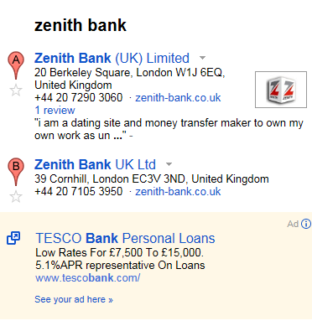

Extra-credit: What other illegal activity is this individual involved in?

I would have to say our individual is very lonely with all the spam he has been getting.

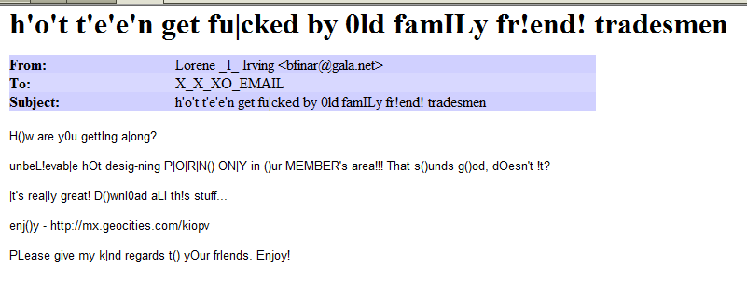

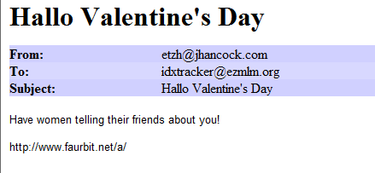

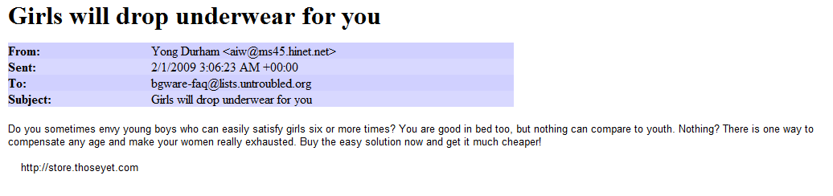

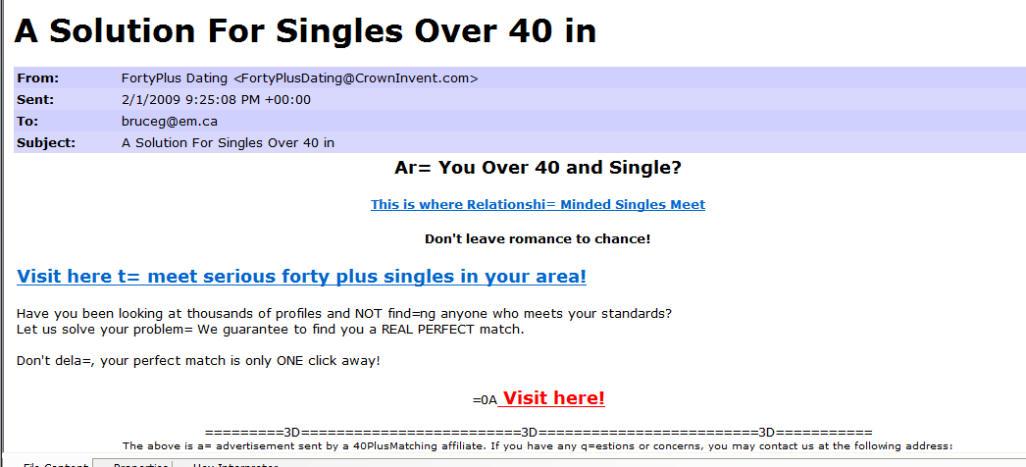

I Suspect that he is in Dept.

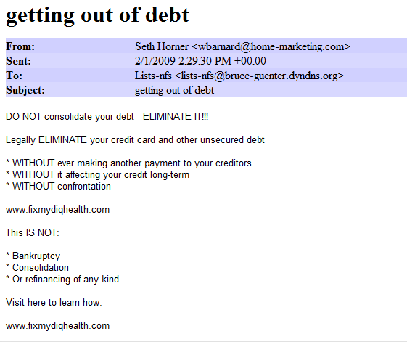

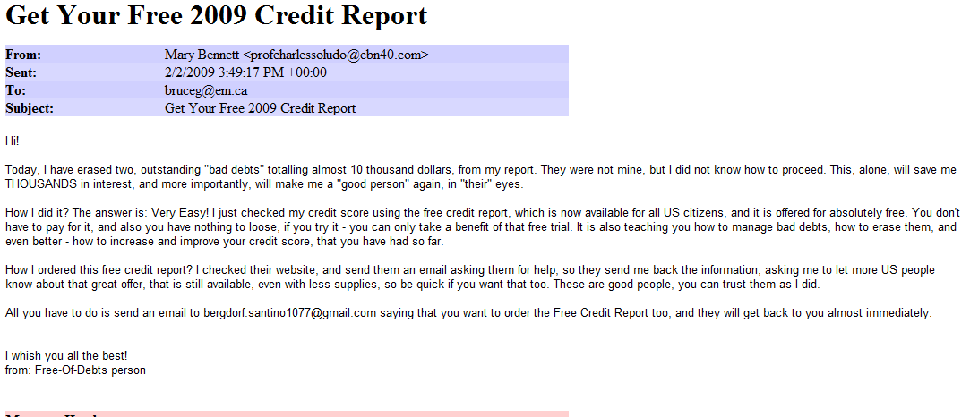

He is also having body function problems I suspect.

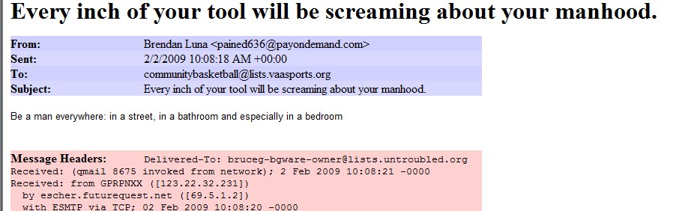

Conclusion:

What I have found is that his name is Bruce. Bruce has 2,197 email and all of his emails are SPAM. I think that Bruce has some problems, with the spam he has been getting. You usually get spam related to what you search for and sign up for on the internet.